PGBackRest : To allow back up and restoration of data in alloydb

Installation Steps:
- Provision Backup Node (if not already created)
- Install PGBackRest on Backup Node

sudo dnf install -y https://download.postgresql.org/pub/repos/yum/reporpms/EL-9-x86_64/pgdg-redhat-repo-latest.noarch.rpm;
sudo dnf install -y https://dl.fedoraproject.org/pub/epel/epel-release-latest-9.noarch.rpm
sudo dnf makecache;
sudo dnf -y install pgbackrest;
sudo groupadd pgbackrest;
sudo adduser -g pgbackrest -n pgbackrest;
sudo mkdir -p /data/backup;
sudo mkdir -p /var/log/pgbackrest;
sudo chown pgbackrest:pgbackrest /data/backup;
sudo chown pgbackrest:pgbackrest /var/log/pgbackrest;
sudo chmod 750 /var/log/pgbackrest;

- Connect to the DB node and find Postgres Data Directory and Postgres Socket Path by connecting to postgres DB and running below command

# If ssl is enabled
PGPASSWORD=$PG_PASSWORD psql "host=$HOSTMACHINE port=$PORT dbname=$DBNAME user=$USERNAME sslmode=verify-full sslrootcert=$ROOT_CERT_PATH sslcert=$SSL_CERT_PATH sslkey=$CERT_KEY_PATH"

# If ssl is disabled
PGPASSWORD=$PG_PASSWORD psql "host=$HOSTMACHINE port=$PORT dbname=$DBNAME user=$USERNAME

# In our testing, below command is used
PGPASSWORD=$PG_PASSWORD psql "host=10.1.0.5 port=6432 dbname=postgres user=postgres sslmode=verify-full sslrootcert=./rootca.crt sslcert=./alloydb.crt sslkey=./alloydb.key"
SHOW data_directory;
SHOW unix_socket_directories;

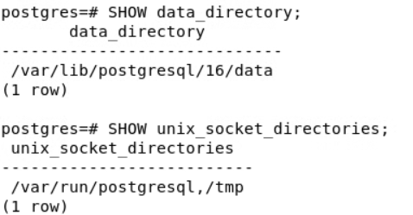

- Modify the pgbackrest configuration on the back node with the below content and modify the permissions

sudo vi /etc/pgbackrest.conf
[global]
repo1-path=/data/backup
log-level-file=info
start-fast=y
archive-copy=y

[standalone]
pg1-host=standalone-db1
pg1-user=postgres
pg1-path=/var/lib/postgresql/16/data
pg1-socket-path=/var/run/postgresql,/tmp

# Permissions
sudo chown pgbackrest:pgbackrest /etc/pgbackrest.conf;
sudo -u pgbackrest chmod 640 /etc/pgbackrest.conf;


- Install PGBackRest on standalone db node and modify the pgbackrest, postgres configuration and restart alloydb

# Installation

sudo dnf install -y https://dl.fedoraproject.org/pub/epel/epel-release-latest-9.noarch.rpm
sudo dnf makecache;
sudo dnf -y install pgbackrest;
# Modify the pgbackrest configuration

Put below data in file /etc/pgbackrest.conf
sudo vi /etc/pgbackrest.conf
[global]
repo1-host=standalone-external1
repo1-host-user=pgbackrest
repo1-path=/data/backup

[standalone]
pg1-path=/var/lib/postgresql/16/data

# Modidy the Permissions
sudo chown postgres:postgres /etc/pgbackrest.conf;
sudo -u postgres chmod 600 /etc/pgbackrest.conf;

# Modidy the Postres Configuration Permissions
Add below line of code in postgresql.conf
sudo vi /var/lib/postgresql/16/data/postgresql.conf
archive_mode = on
archive_command = 'pgbackrest --config=/etc/pgbackrest.conf --stanza=standalone archive-push %p'

# Restart Alloy DB
sudo systemctl restart alloydbomni-16

- Setup two way passwordless ssh between standalone db node and backup node.

# To allow passwordless to backup node access from db node.

Create the ssh key pair for pgbackrest user on backup node. (use ssh-keygen)
Copy the public key id_rsa.pub and make the entry of this key in the authorized_keys on the standalone db node.(for postgres user)

Verify passwordless access using
ssh pgbackrest@$BACKUP_NODE
ssh pgbackrest@standalone-external1
# To allow passwordless to db node access from backup node.
Create the ssh key pair for postgres user on db node. (use ssh-keygen)
Copy the public key id_rsa.pub and make the entry of this key in the authorized_keys on the backup db node (for pgbackrest user)

Verify passwordless access using
ssh postgres@$DB_NODE
Verrify ssh postgres@standalone-db1

- Create Stanza on Backup VM using below command

A stanza is the configuration for a PostgreSQL database cluster that defines where it is located, how it will be backed up, archiving options, etc. Most db servers will only have one PostgreSQL database cluster and therefore one stanza, whereas backup servers will have a stanza for every database cluster that needs to be backed up.

SSH into To Backup VM

# Create
sudo -u pgbackrest pgbackrest --config=/etc/pgbackrest.conf --stanza=standalone stanza-create

#Verify
sudo -u pgbackrest pgbackrest --config=/etc/pgbackrest.conf --stanza=standalone check


Backup Steps:
- Create Database and insert dummy data on db node

# Connect to postgres using psql client

PGPASSWORD=$PG_PASSWORD psql "host=10.1.0.5 port=6432 dbname=postgres user=postgres sslmode=verify-full sslrootcert=./rootca.crt sslcert=./alloydb.crt sslkey=./alloydb.key"
CREATE DATABASE pocdb;
\c pocdb;
CREATE TABLE employees (
employee_id SERIAL PRIMARY KEY,
first_name VARCHAR(50),
last_name VARCHAR(50),
department VARCHAR(50),
salary NUMERIC(10, 2),
hire_date DATE DEFAULT CURRENT_DATE
);
INSERT INTO employees (first_name, last_name, department, salary)
VALUES
('Alice', 'Johnson', 'Engineering', 85000),
('Bob', 'Smith', 'Sales', 60000),
('Charlie', 'Williams', 'Marketing', 75000),
('Diana', 'Brown', 'HR', 50000),
('Eve', 'Davis', 'Engineering', 95000);


- Validate the data is inserted
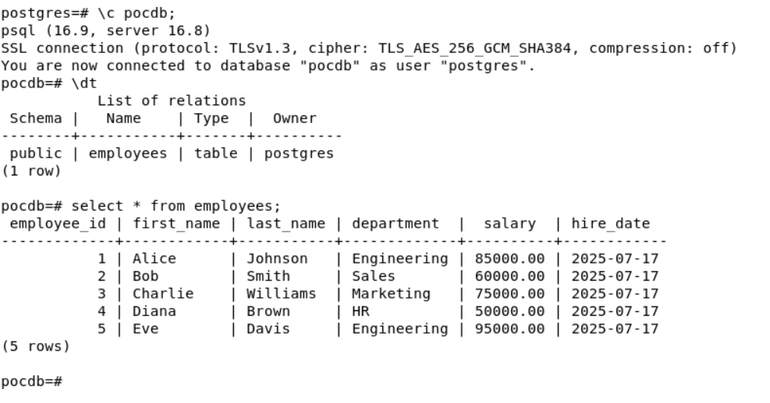

- SSH into backup node and perform the full back up of db node
# Take Full Backup
sudo -u pgbackrest pgbackrest --config=/etc/pgbackrest.conf --stanza=standalone --type=full backup
#Verify if the backup is created
sudo -u pgbackrest pgbackrest --config=/etc/pgbackrest.conf --stanza=standalone info

#Check pgbackRest logs
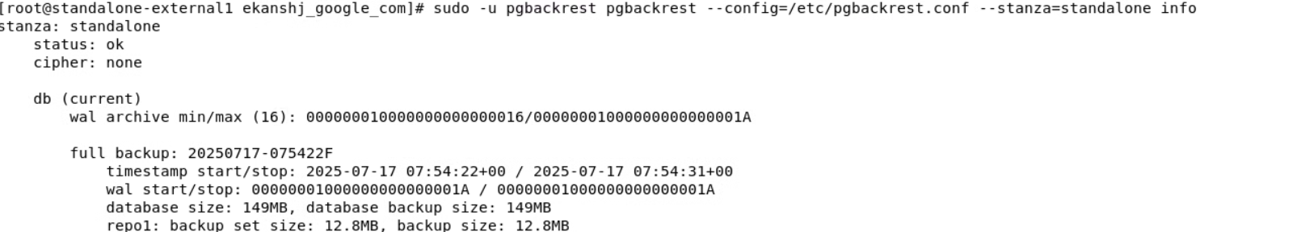

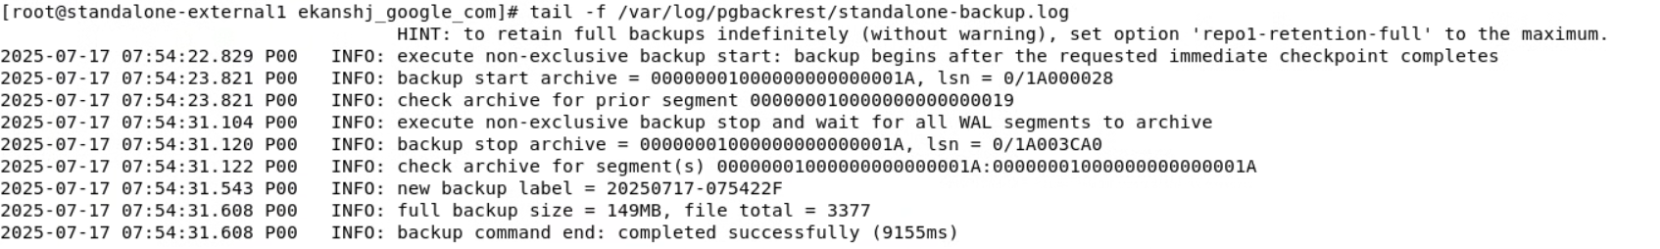

- To perform the differential backup

# SSH into DB node and insert more data in the employees table of pocdb we created
INSERT INTO employees (first_name, last_name, department, salary)
VALUES
('Frank', 'Anderson', 'IT', 80000),
('Grace', 'Taylor', 'Engineering', 88000);

# SSH into Backup node and perform differential backup

sudo -u pgbackrest pgbackrest --config=/etc/pgbackrest.conf --stanza=standalone --type=diff backup

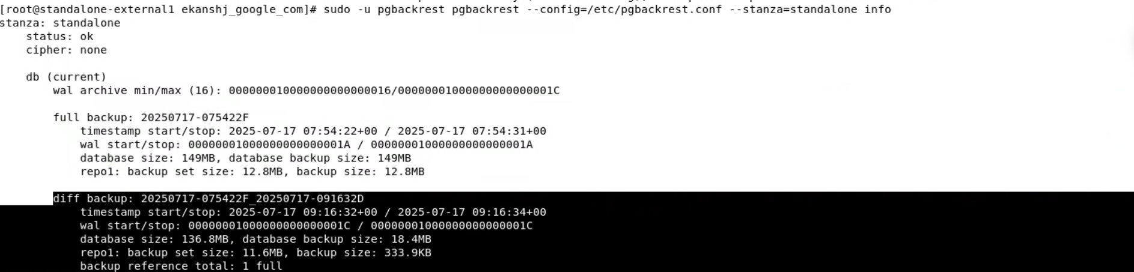

- To perform the incremental backup

# SSH into DB node and insert more data in the employees table of pocdb we created

INSERT INTO employees (first_name, last_name, department, salary)
VALUES
('Isaac', 'Newton', 'Research', 120000),
('Tesla', 'Nikola', 'Engineering', 130000);
# SSH into Backup node and perform incremental backup
sudo -u pgbackrest pgbackrest --config=/etc/pgbackrest.conf --stanza=standalone --type=incr backup

# SSH into DB node and insert some more data in the employees table of pocdb we created (This will be reference later while restoring)

INSERT INTO employees (first_name, last_name, department, salary)
VALUES
('Garim', 'Hola', 'DataScience', 140000);
# SSH into Backup node and perform incremental backup again
sudo -u pgbackrest pgbackrest --config=/etc/pgbackrest.conf --stanza=standalone --type=incr backup


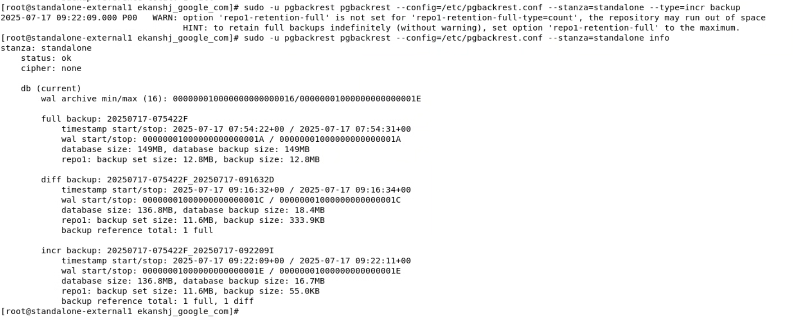

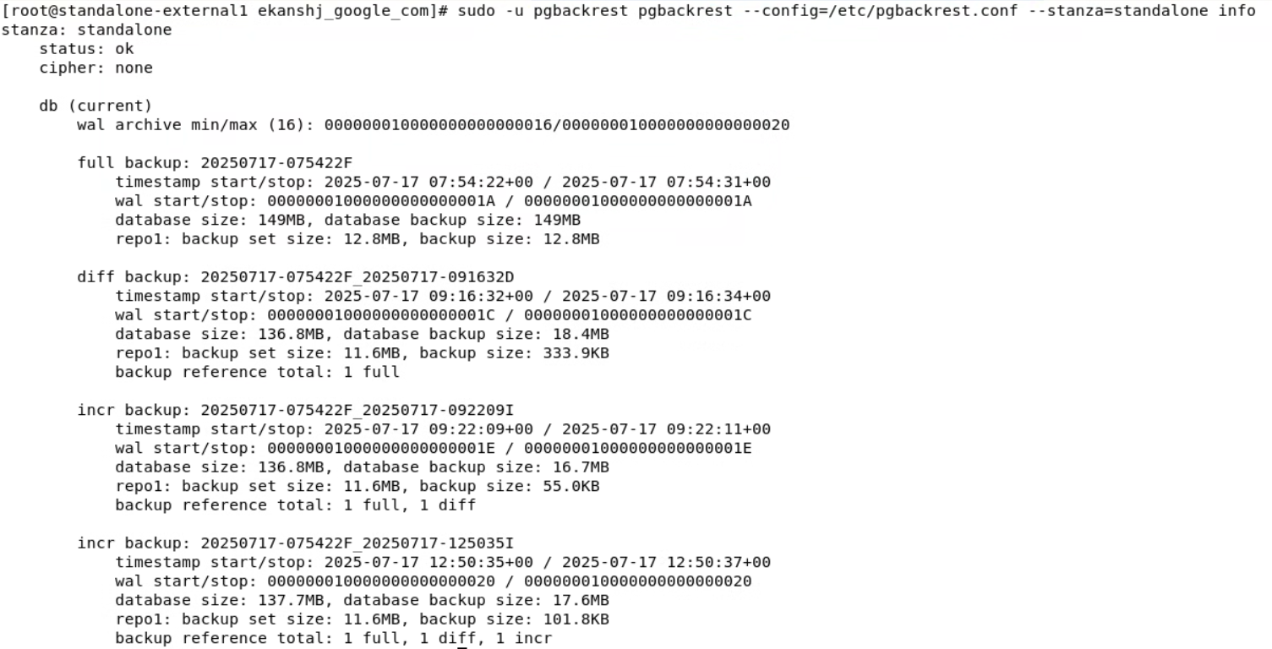
Note: We are able to take the backup without passing any ssl configuration in pgbackRest even though ssl is enforced at db level.

Restore Steps:

- Restore full data from Differential Backups/ Restore PITR (Same steps)

# Differential Backup (automatically includes refernce of last full Backup) -> Restores to Latest Full Database

sudo systemctl stop alloydbomni-16;
sudo rm -rf /var/lib/postgresql/16/data;
sudo mkdir -p /var/lib/postgresql/16/data;
sudo chown -R postgres:postgres /var/lib/postgresql/16/data;
sudo chmod 0700 /var/lib/postgresql/16/data;

sudo -u postgres pgbackrest --config=/etc/pgbackrest.conf --stanza=standalone --type=time --target="2025-07-17 09:16:32" --target-action=promote restore

Observation:
full data is restored upto last diffential back up timestamp

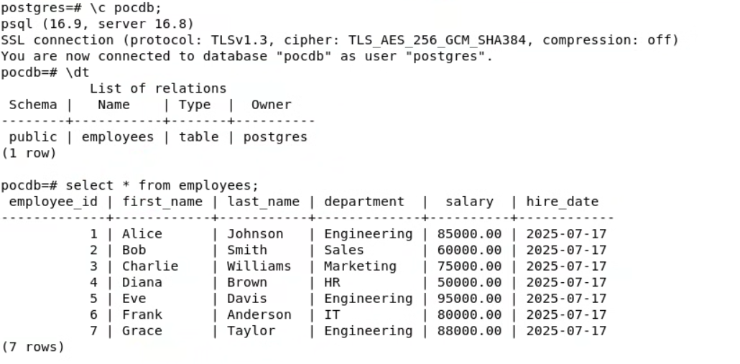

- Restore deleted table/data

1) Delete any record from the table
2) Stop the database
3) Restore the backup using --delta
sudo -u postgres pgbackrest --config=/etc/pgbackrest.conf --stanza=standalone --type=time --target="2025-07-17 09:16:32" --target-action=promote restore --delta
4) Start the database
5) Validate if deleted record exist

Observation:
record is restored
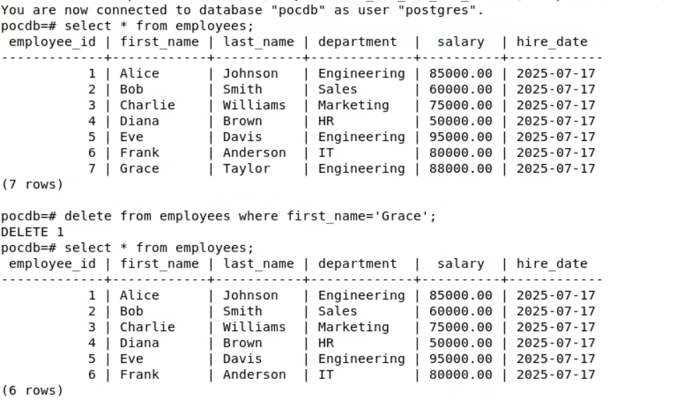

After Restore

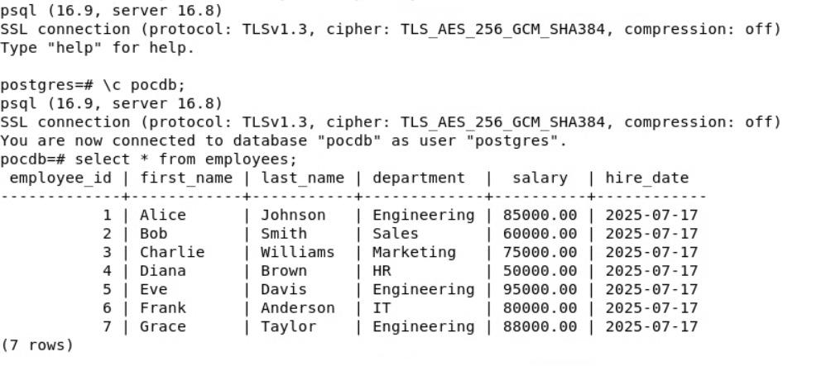
sudo -u postgres pgbackrest --config=/etc/pgbackrest.conf --stanza=standalone --target-action=promote restore --delta

- Backup Retention

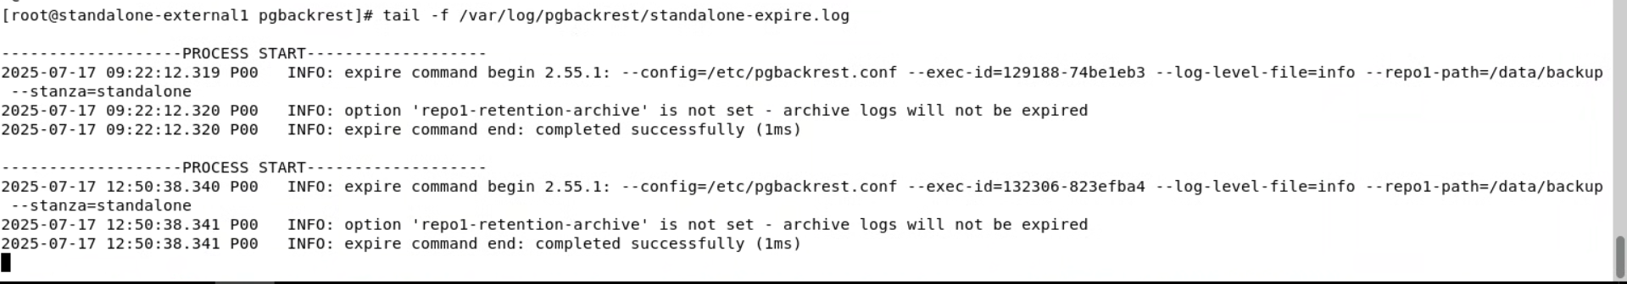
Set repo1-retention-archive

- Check PGbackrest Logs for Restoration on DB node
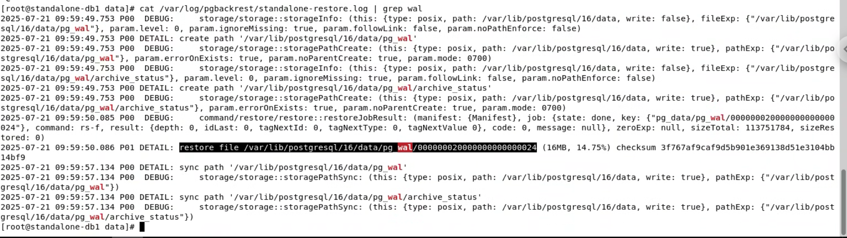

How WAL are stored on db
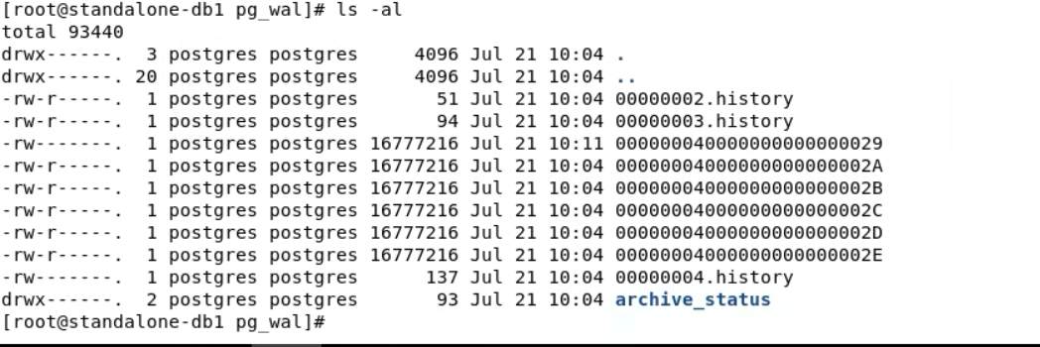

How WAL are backed up backup node
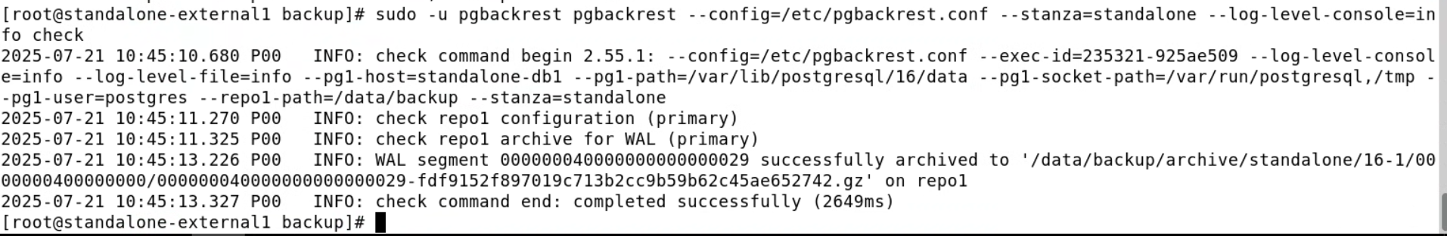
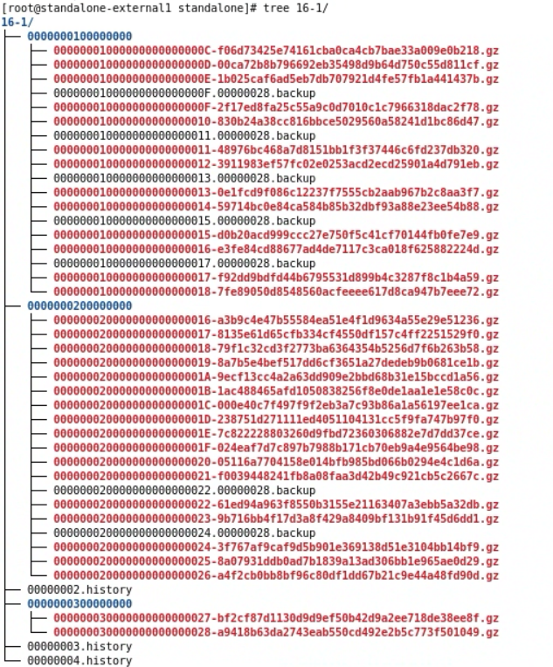
Postgres Logs
